**TASK 7.2D(SIT313)**

**Submitted by:- Jeetasha(2210994796)**

* **Github Repository Link :-**

[**https://github.com/JeetashaArora/SIT313-/tree/main/Task%207.2D**](https://github.com/JeetashaArora/SIT313-/tree/main/Task%207.2D)

* **YouTube Video Link :-**

[**https://youtu.be/zNj4xY8n2uA**](https://youtu.be/zNj4xY8n2uA)

* **Code Screenshots:-**
* **Article Component**

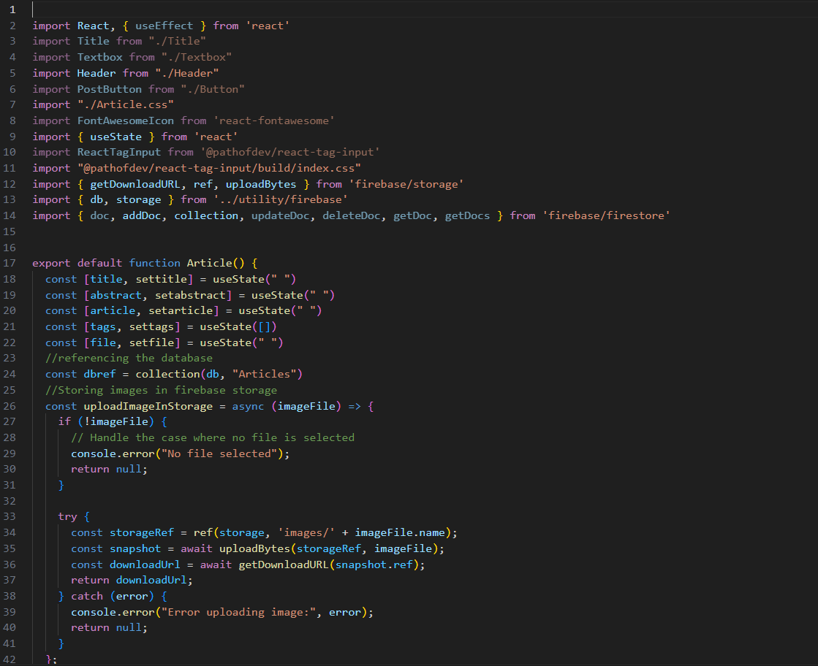

* **Button Component**

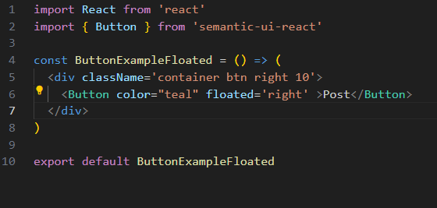

* **Navbar Component**

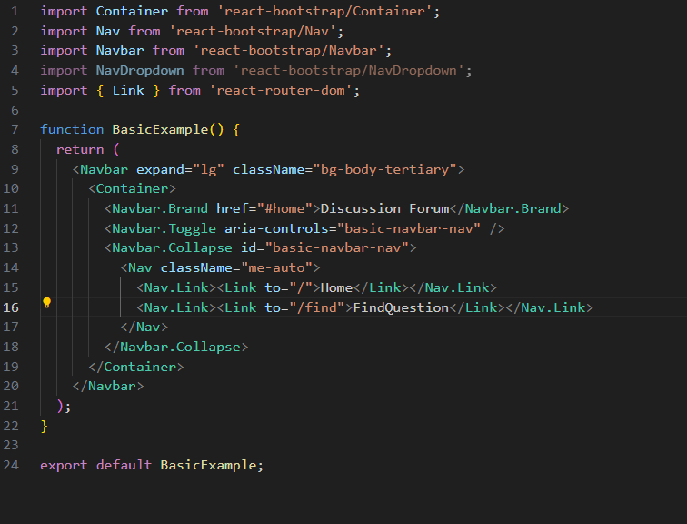

* **PostType Component**

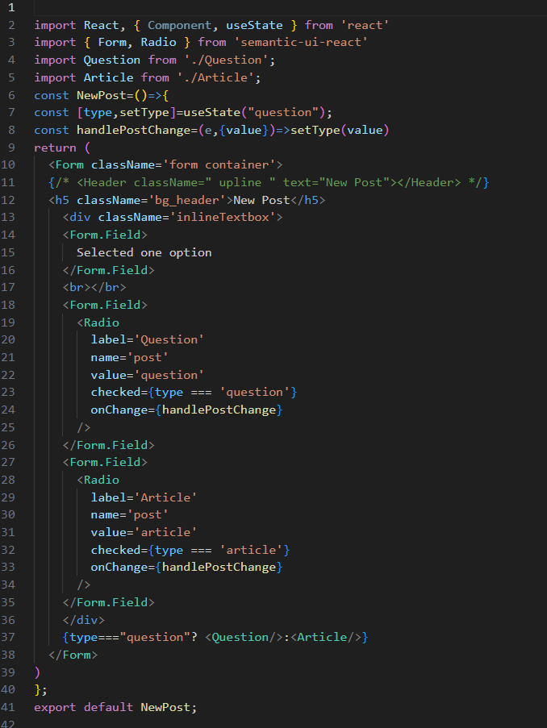

* **QuestionCard Component**

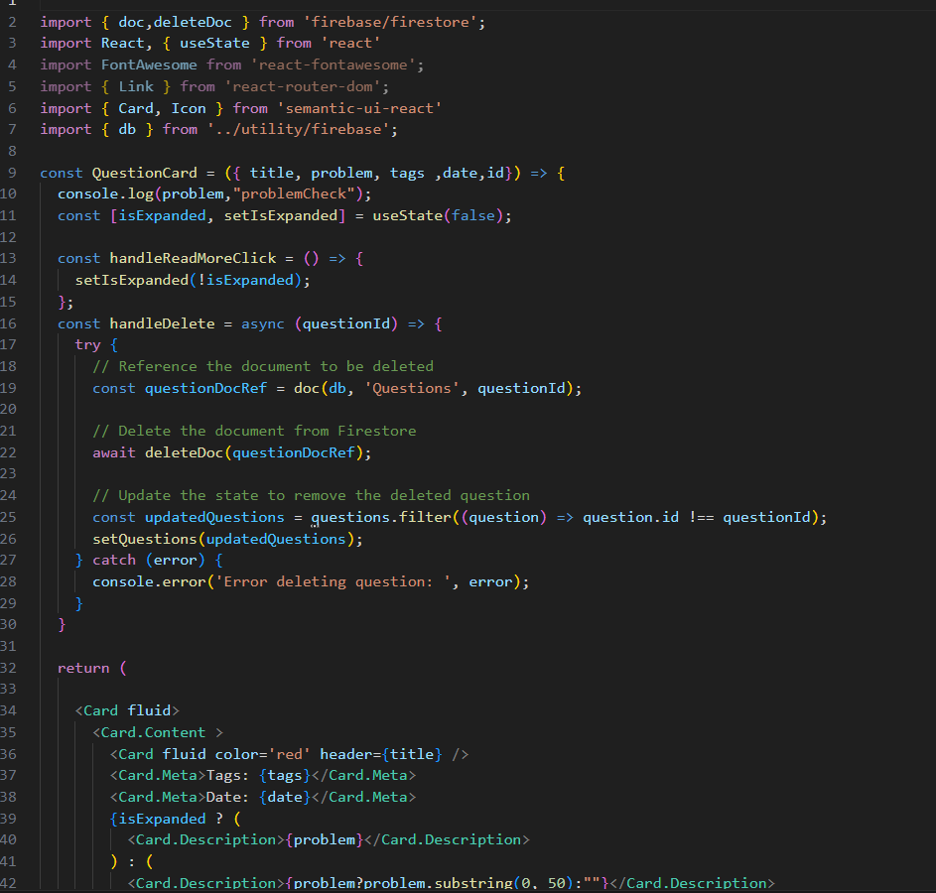

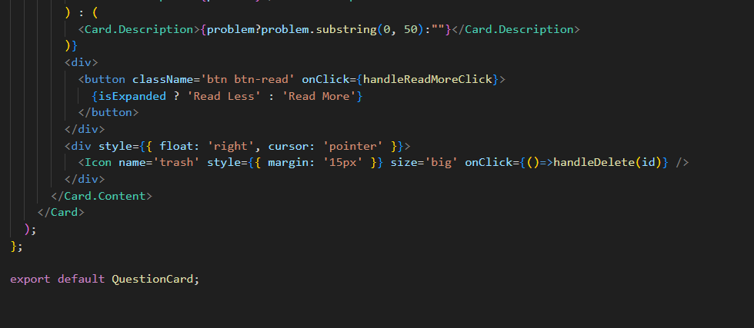

* **Question Component**

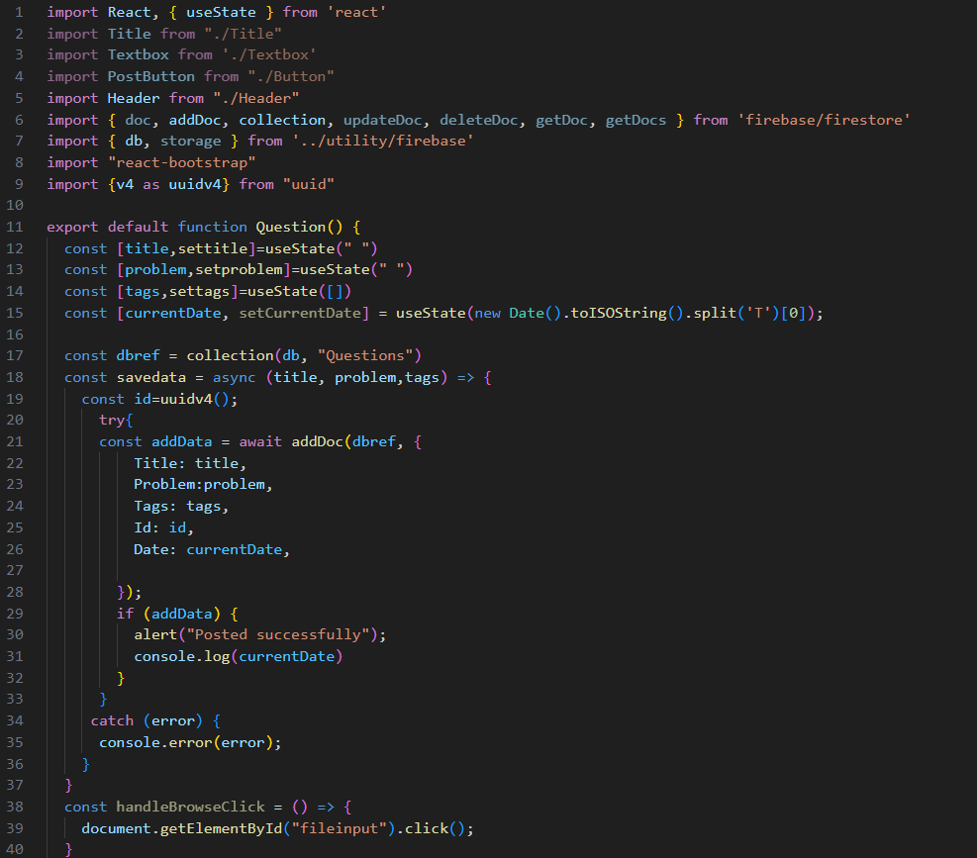

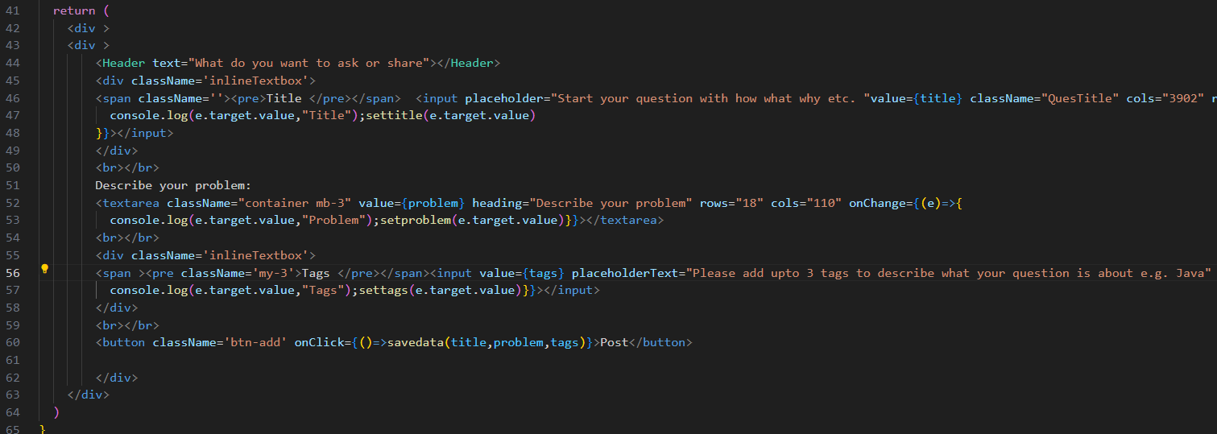

* **QuestionList Component**

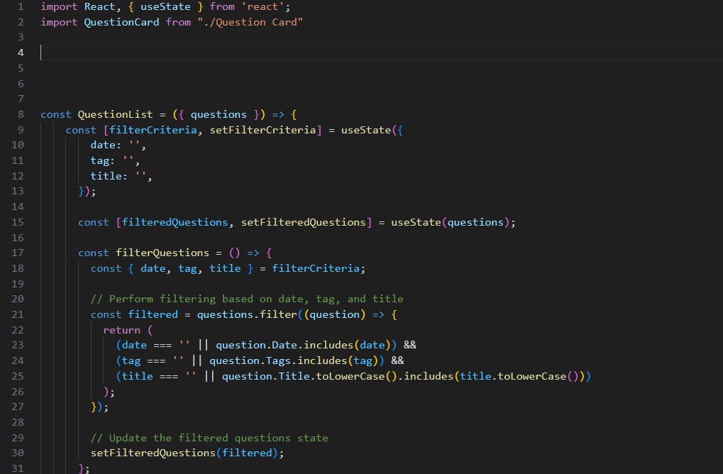

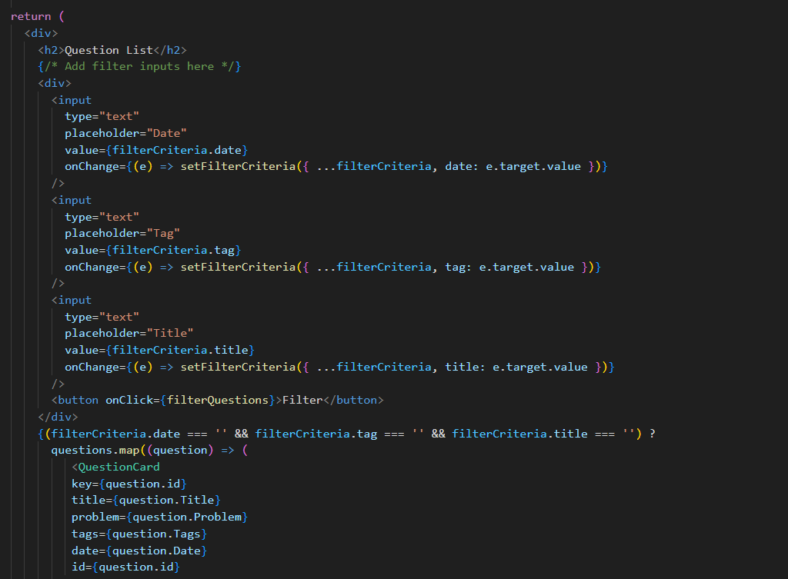

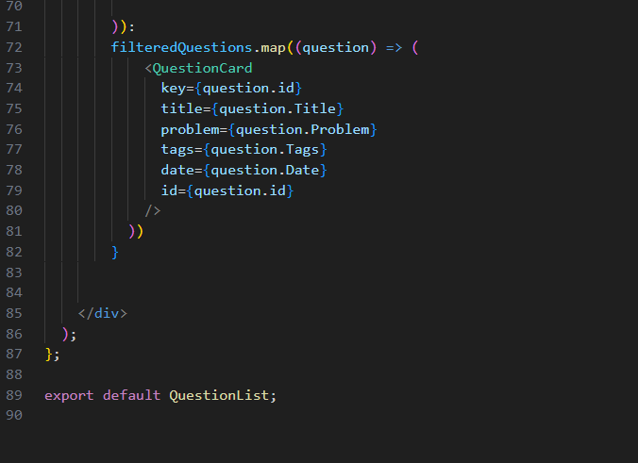

* **FindQuesPage Component**

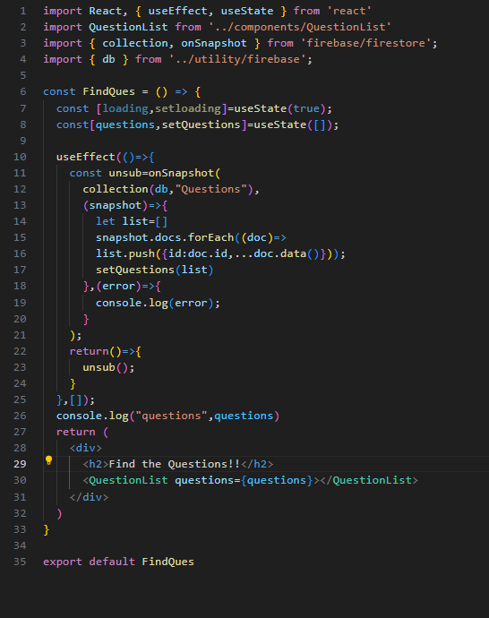

* **Firebase.js**

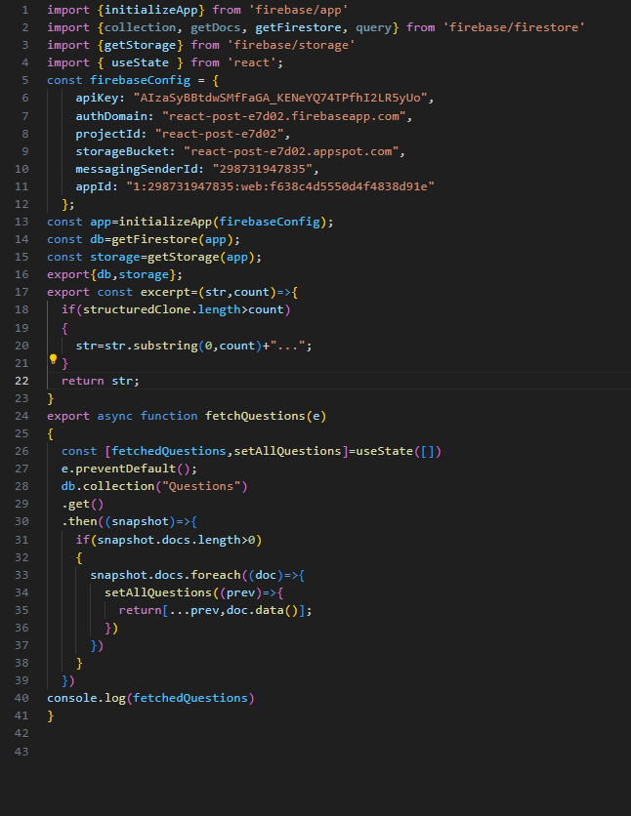

* **App.js**

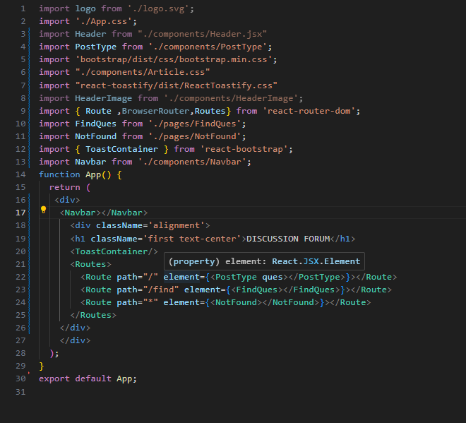

* **Screenshot of Questions Page**

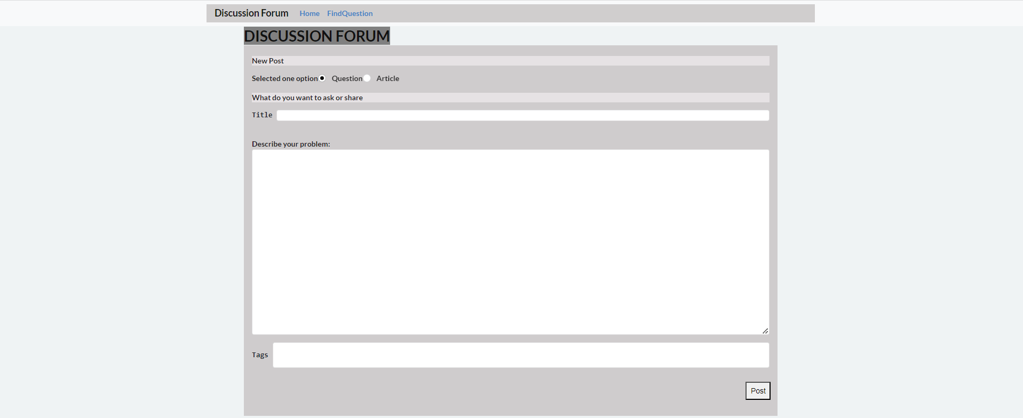

* **Screenshot of Articles Page**

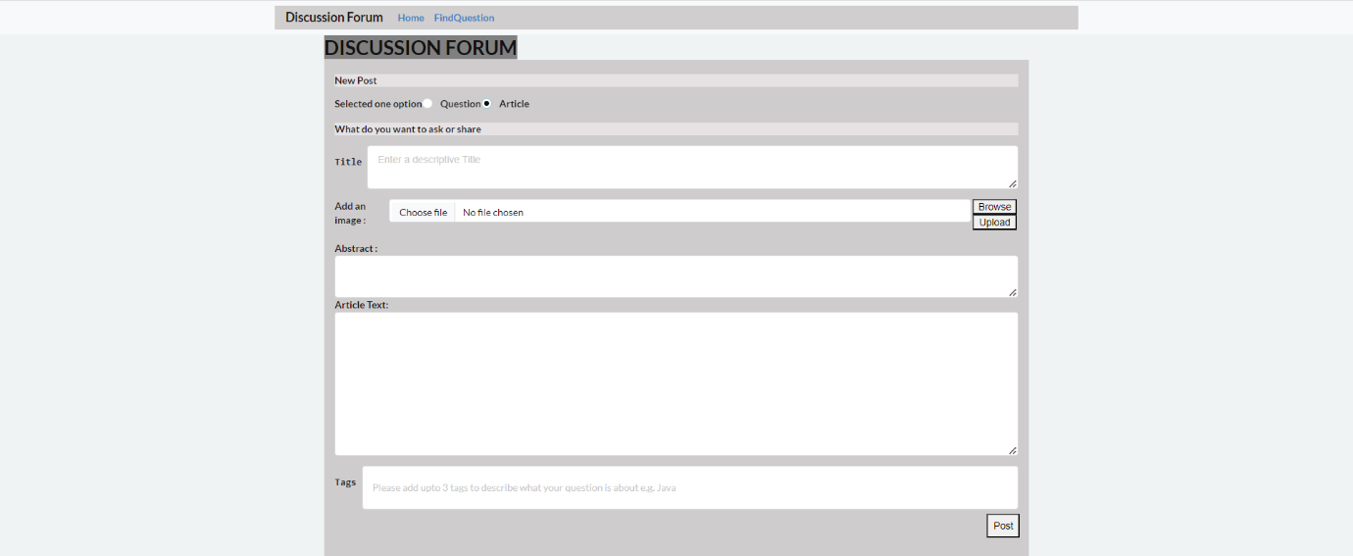

* **Screenshot of Findquestions Page**

